***Most Recent Prompt***

**Generate a complex HTML website with CSS, live external images from unsplash, links to external websites, forms, and input fields referencing Cloudfare.**

JavaScript event listeners:

**Generate JavaScript event listeners for this webpage.**

HTML Generation

**Generate a complex HTML website for a dog shelter with live external images, forms, and input fields.**

**Unsplash images**

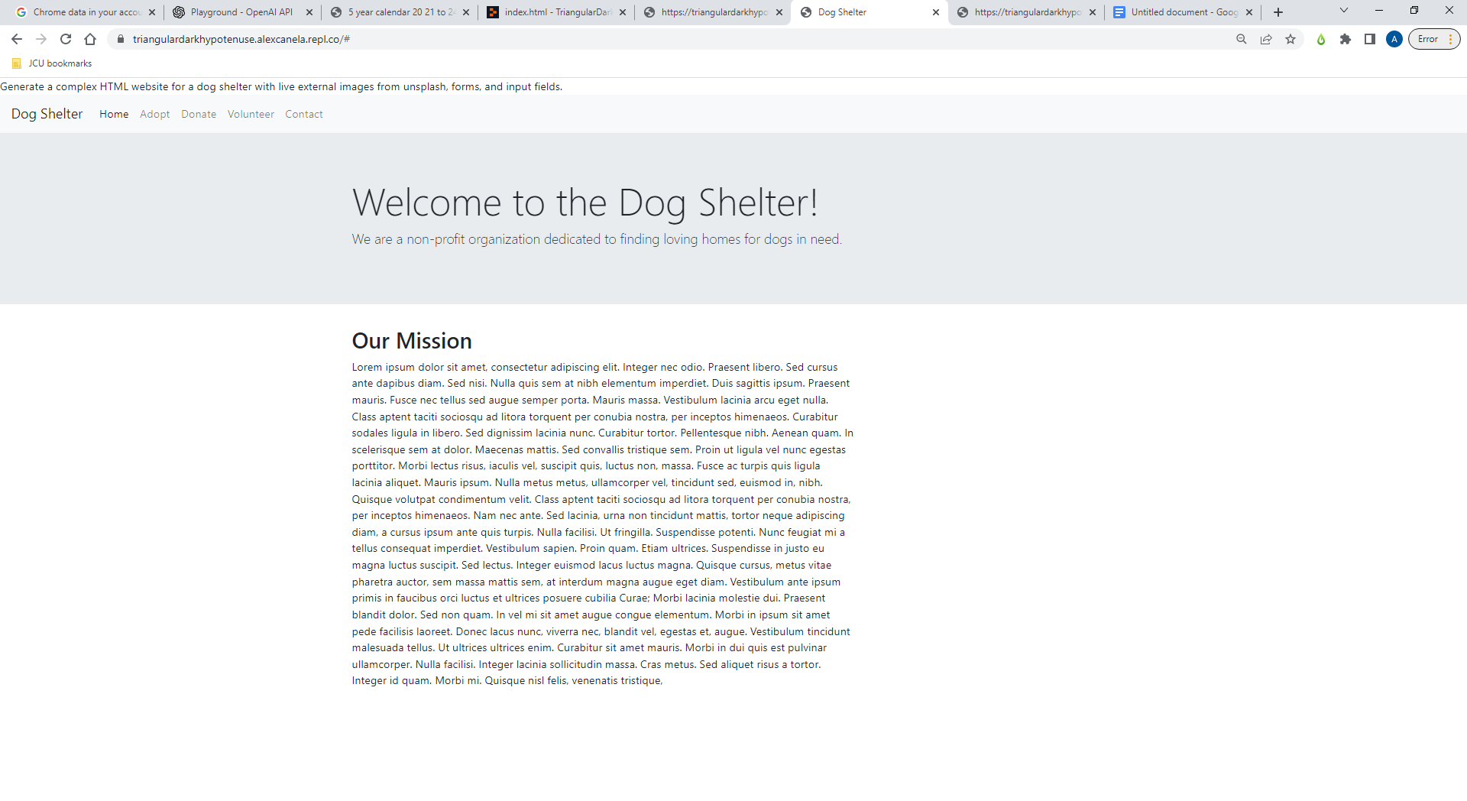

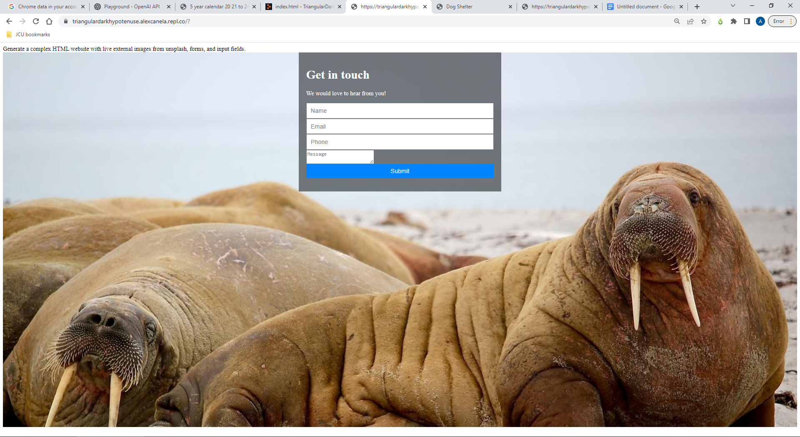

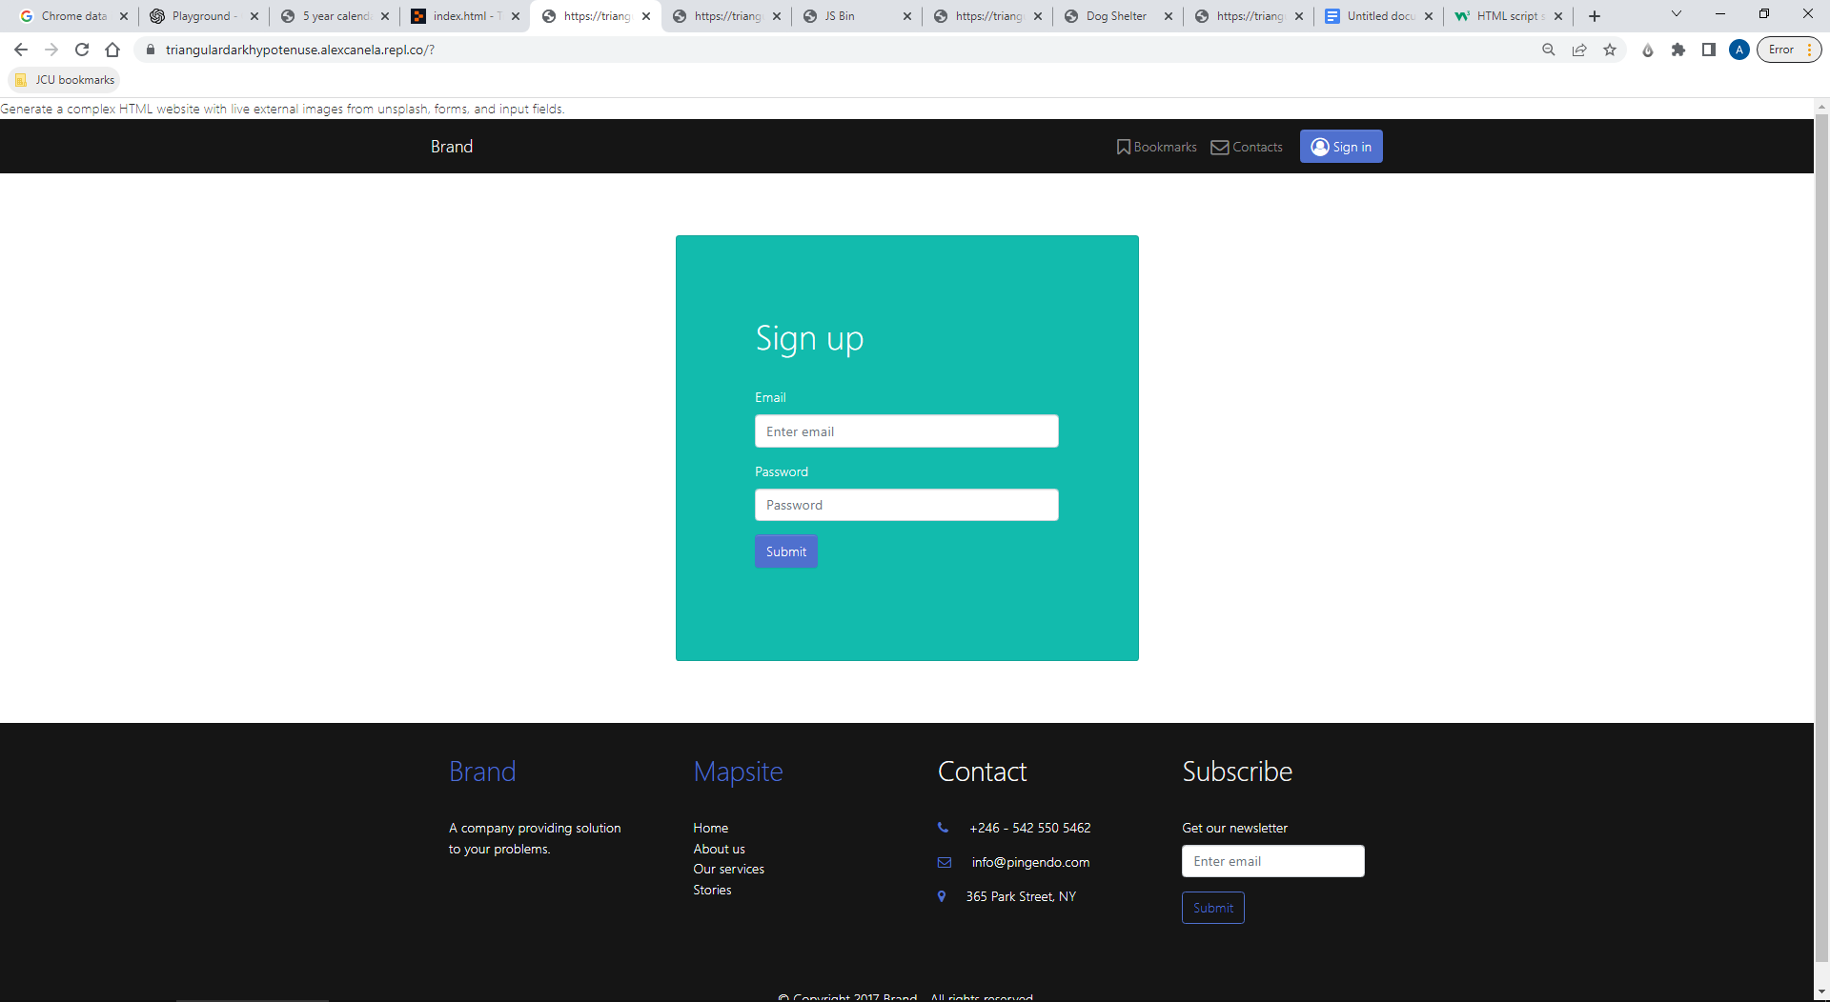

**Prompting GPT-3 to use external style-sheets and scripts:**

***“Referencing GitHUb, generate a complex HTML website with live external images from unsplash, forms, and input fields.”***

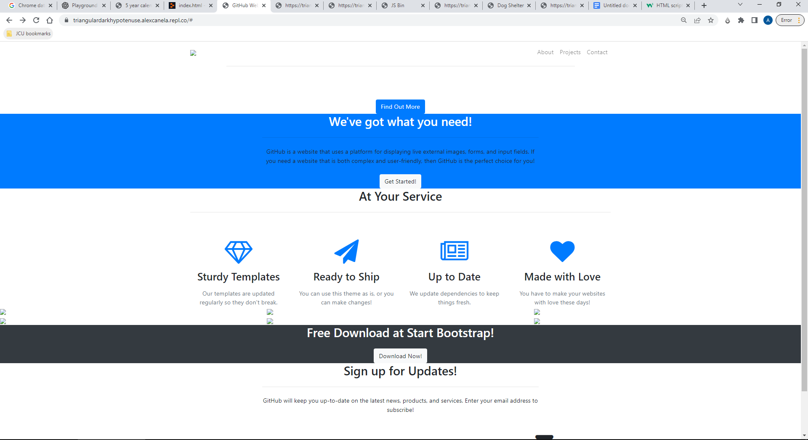

**Prompting Cloudfare to use external style-sheets and scripts:**

***“Referencing Cloudfare, generate a complex HTML website with live external images from unsplash, forms, and input fields.”***

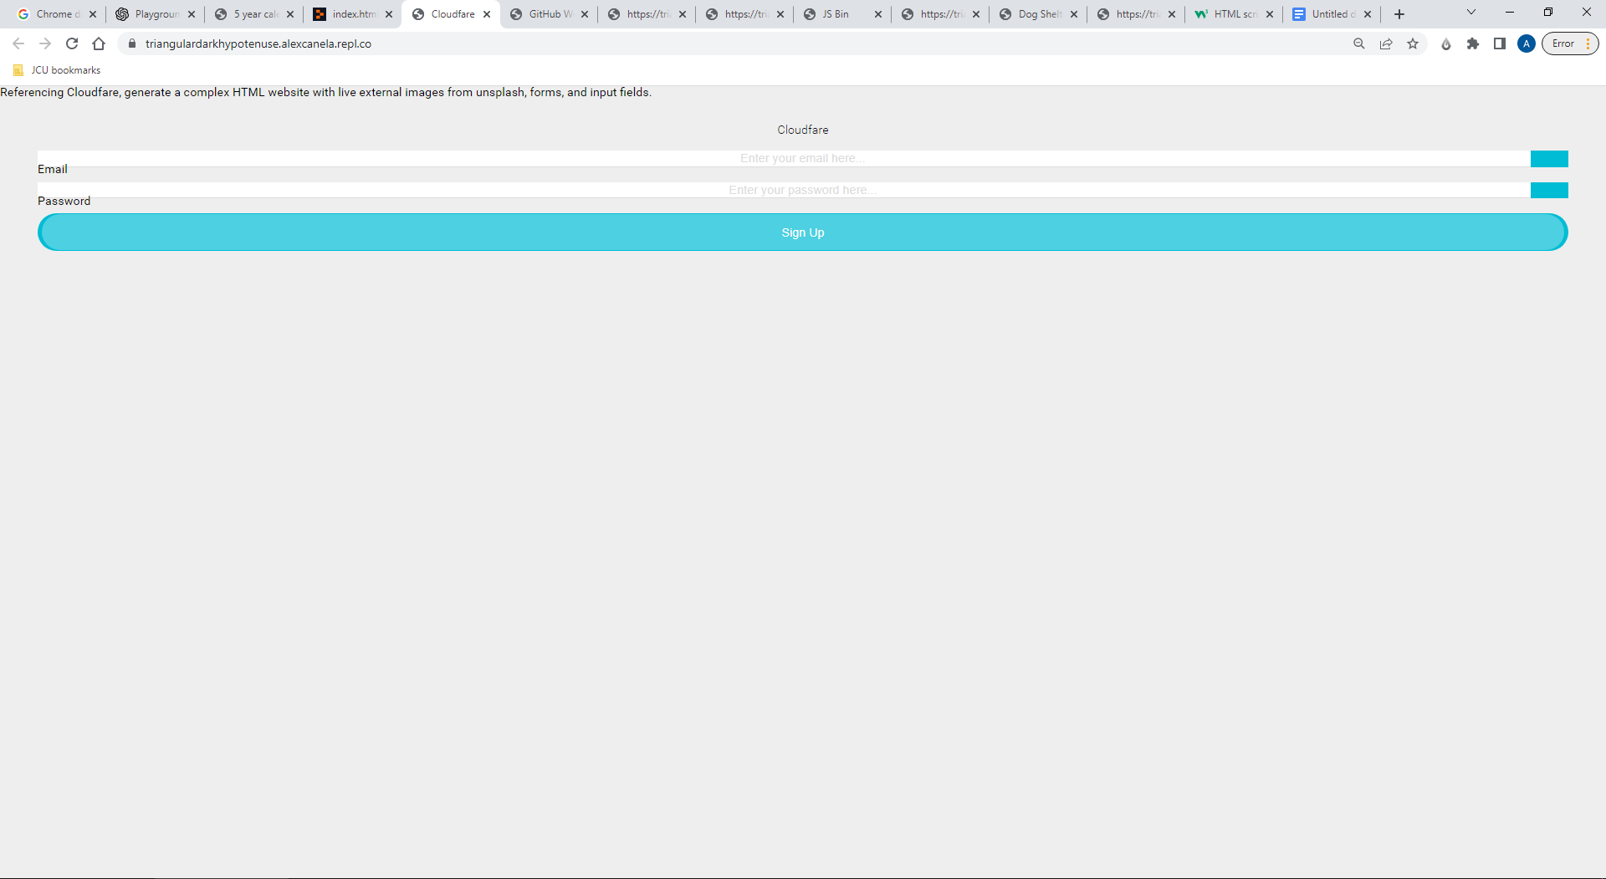

**Attempt #2: “Generate a complex HTML website with live external images from unsplash, forms, and input fields referencing Cloudfare.”**

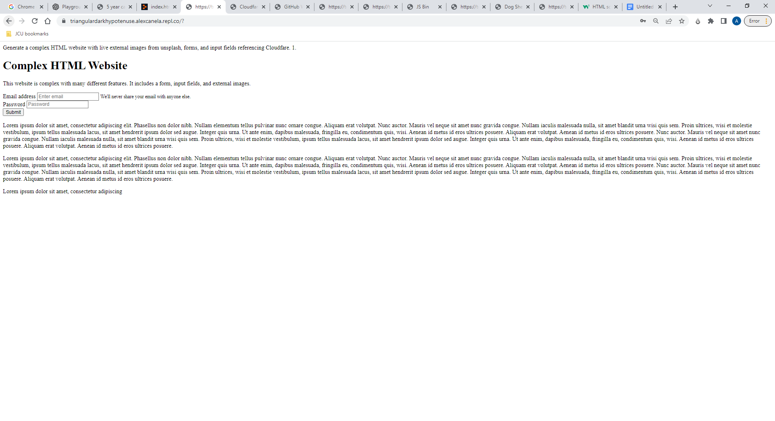

**Pg. 1:**

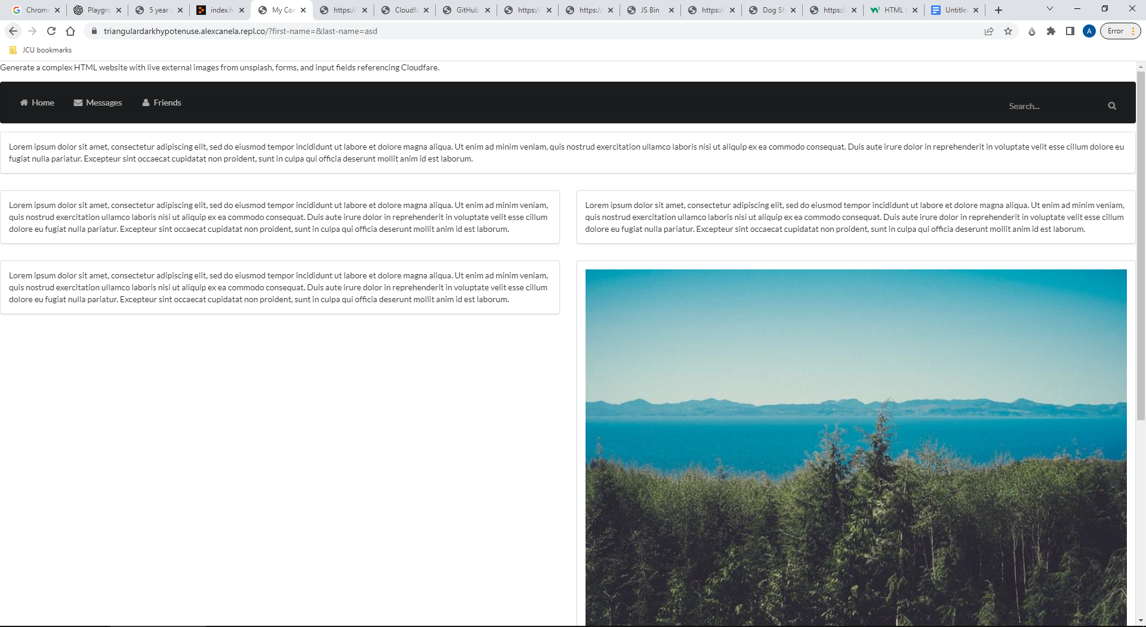

**Pg. 2:**

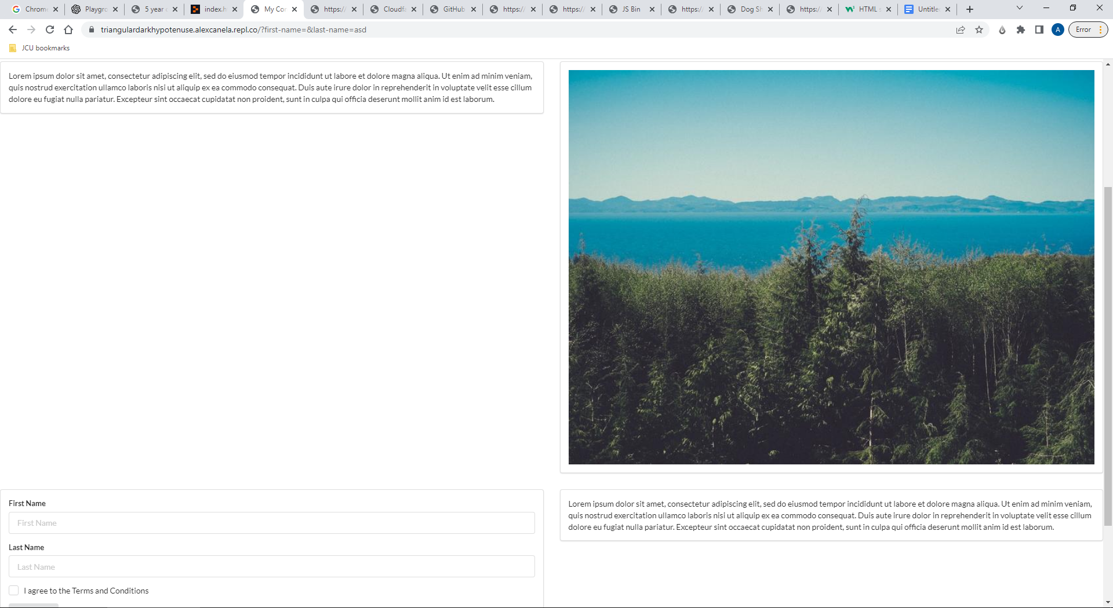

**“Generate a complex HTML website with CSS, live external images from unsplash, forms, and input fields referencing Cloudfare”**

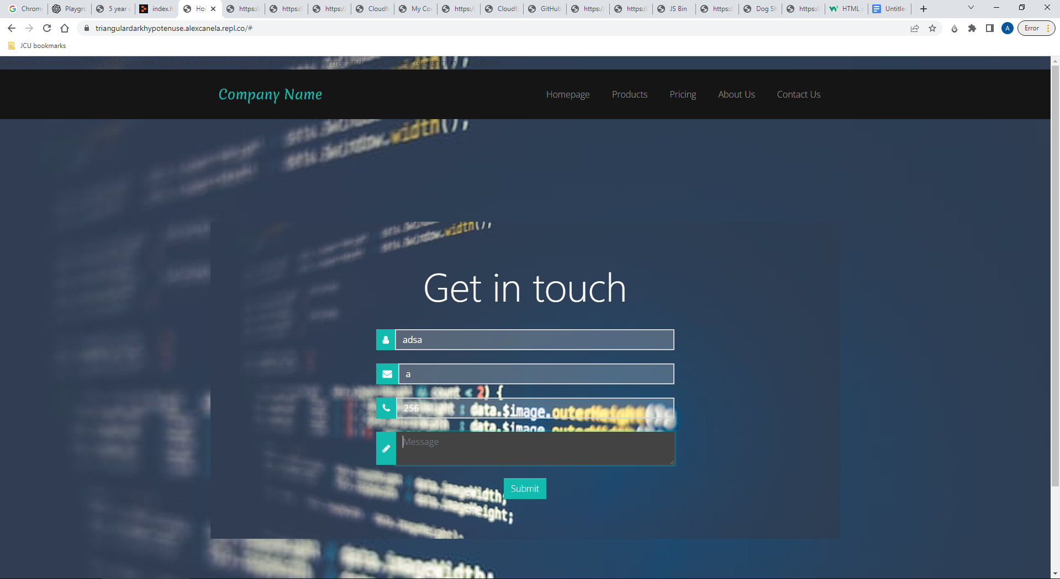

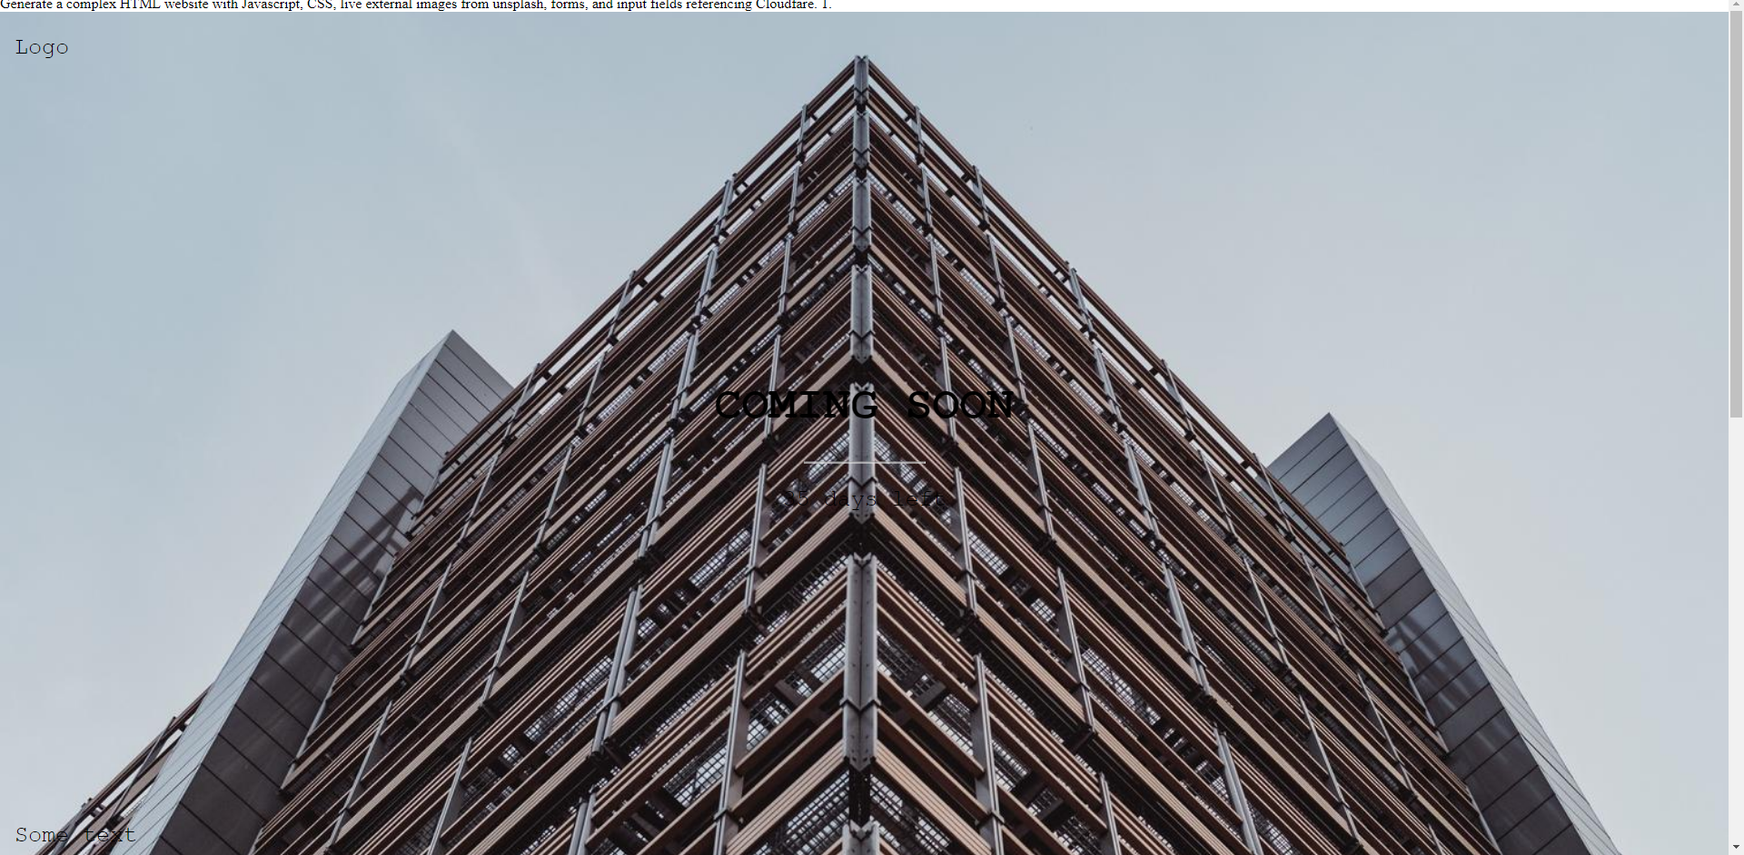

**Generate a complex HTML website with CSS, live external images from unsplash, links to external websites, forms, and input fields referencing Cloudfare.**

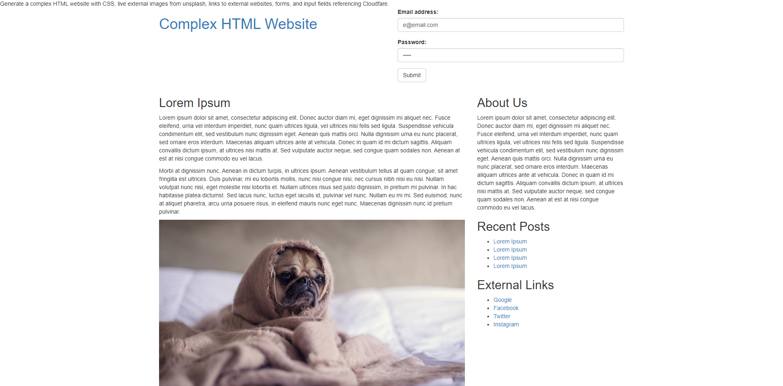

**name = "aiohttp"**

**version = "3.8.3"**

**description = "Async http client/server framework (asyncio)"**

**category = "main"**

**optional = false**

**python-versions = ">=3.6"**

**[package.dependencies]**

**aiosignal = ">=1.1.2"**

**async-timeout = ">=4.0.0a3,<5.0"**

**attrs = ">=17.3.0"**

**charset-normalizer = ">=2.0,<3.0"**

**frozenlist = ">=1.1.1"**

**multidict = ">=4.5,<7.0"**

**yarl = ">=1.0,<2.0"**

**[package.extras]**

**speedups = ["aiodns", "brotli", "cchardet"]**

**[[package]]**

**name = "aiosignal"**

**version = "1.2.0"**

**description = "aiosignal: a list of registered asynchronous callbacks"**

**category = "main"**

**optional = false**

**python-versions = ">=3.6"**

**[package.dependencies]**

**frozenlist = ">=1.1.0"**

**[[package]]**

**name = "async-timeout"**

**version = "4.0.2"**

**description = "Timeout context manager for asyncio programs"**

**category = "main"**

**optional = false**

**python-versions = ">=3.6"**

**[[package]]**

**name = "attrs"**

**version = "22.1.0"**

**description = "Classes Without Boilerplate"**

**category = "main"**

**optional = false**

**python-versions = ">=3.5"**

**[package.extras]**

**dev = ["coverage[toml] (>=5.0.2)", "hypothesis", "pympler", "pytest (>=4.3.0)", "mypy (>=0.900,!=0.940)", "pytest-mypy-plugins", "zope.interface", "furo", "sphinx", "sphinx-notfound-page", "pre-commit", "cloudpickle"]**

**docs = ["furo", "sphinx", "zope.interface", "sphinx-notfound-page"]**

**tests = ["coverage[toml] (>=5.0.2)", "hypothesis", "pympler", "pytest (>=4.3.0)", "mypy (>=0.900,!=0.940)", "pytest-mypy-plugins", "zope.interface", "cloudpickle"]**

**tests_no_zope = ["coverage[toml] (>=5.0.2)", "hypothesis", "pympler", "pytest (>=4.3.0)", "mypy (>=0.900,!=0.940)", "pytest-mypy-plugins", "cloudpickle"]**

**[[package]]**

**name = "certifi"**

**version = "2022.9.24"**

**description = "Python package for providing Mozilla's CA Bundle."**

**category = "main"**

**optional = false**

**python-versions = ">=3.6"**

**[[package]]**

**name = "charset-normalizer"**

**version = "2.1.1"**

**description = "The Real First Universal Charset Detector. Open, modern and actively maintained alternative to Chardet."**

**category = "main"**

**optional = false**

**python-versions = ">=3.6.0"**

**[package.extras]**

**unicode_backport = ["unicodedata2"]**

**[[package]]**

**name = "click"**

**version = "8.1.3"**

**description = "Composable command line interface toolkit"**

**category = "main"**

**optional = false**

**python-versions = ">=3.7"**

**[package.dependencies]**

**colorama = {version = "*", markers = "platform_system == \"Windows\""}**

**[[package]]**

**name = "colorama"**

**version = "0.4.5"**

**description = "Cross-platform colored terminal text."**

**category = "main"**

**optional = false**

**python-versions = ">=2.7, !=3.0.*, !=3.1.*, !=3.2.*, !=3.3.*, !=3.4.*"**

**[[package]]**

**name = "debugpy"**

**version = "1.6.3"**

**description = "An implementation of the Debug Adapter Protocol for Python"**

**category = "dev"**

**optional = false**

**python-versions = ">=3.7"**

**[[package]]**

**name = "flask"**

**version = "2.2.2"**

**description = "A simple framework for building complex web applications."**

**category = "main"**

**optional = false**

**python-versions = ">=3.7"**

**[package.dependencies]**

**click = ">=8.0"**

**importlib-metadata = {version = ">=3.6.0", markers = "python_version < \"3.10\""}**

**itsdangerous = ">=2.0"**

**Jinja2 = ">=3.0"**

**Werkzeug = ">=2.2.2"**

**[package.extras]**

**async = ["asgiref (>=3.2)"]**

**dotenv = ["python-dotenv"]**

**[[package]]**

**name = "frozenlist"**

**version = "1.3.1"**

**description = "A list-like structure which implements collections.abc.MutableSequence"**

**category = "main"**

**optional = false**

**python-versions = ">=3.7"**

**[[package]]**

**name = "idna"**

**version = "3.4"**

**description = "Internationalized Domain Names in Applications (IDNA)"**

**category = "main"**

**optional = false**

**python-versions = ">=3.5"**

**[[package]]**

**name = "importlib-metadata"**

**version = "5.0.0"**

**description = "Read metadata from Python packages"**

**category = "main"**

**optional = false**

**python-versions = ">=3.7"**

**[package.dependencies]**

**zipp = ">=0.5"**

**[package.extras]**

**docs = ["sphinx (>=3.5)", "jaraco.packaging (>=9)", "rst.linker (>=1.9)", "furo", "jaraco.tidelift (>=1.4)"]**

**perf = ["ipython"]**

**testing = ["pytest (>=6)", "pytest-checkdocs (>=2.4)", "pytest-flake8", "flake8 (<5)", "pytest-cov", "pytest-enabler (>=1.3)", "packaging", "pyfakefs", "flufl.flake8", "pytest-perf (>=0.9.2)", "pytest-black (>=0.3.7)", "pytest-mypy (>=0.9.1)", "importlib-resources (>=1.3)"]**

**[[package]]**

**name = "itsdangerous"**

**version = "2.1.2"**

**description = "Safely pass data to untrusted environments and back."**

**category = "main"**

**optional = false**

**python-versions = ">=3.7"**

**[[package]]**

**name = "jedi"**

**version = "0.18.1"**

**description = "An autocompletion tool for Python that can be used for text editors."**

**category = "dev"**

**optional = false**

**python-versions = ">=3.6"**

**[package.dependencies]**

**parso = ">=0.8.0,<0.9.0"**

**[package.extras]**

**qa = ["flake8 (==3.8.3)", "mypy (==0.782)"]**

**testing = ["Django (<3.1)", "colorama", "docopt", "pytest (<7.0.0)"]**

**[[package]]**

**name = "jinja2"**

**version = "3.1.2"**

**description = "A very fast and expressive template engine."**

**category = "main"**

**optional = false**

**python-versions = ">=3.7"**

**[package.dependencies]**

**MarkupSafe = ">=2.0"**

**[package.extras]**

**i18n = ["Babel (>=2.7)"]**

**[[package]]**

**name = "markupsafe"**

**version = "2.1.1"**

**description = "Safely add untrusted strings to HTML/XML markup."**

**category = "main"**

**optional = false**

**python-versions = ">=3.7"**

**[[package]]**

**name = "multidict"**

**version = "6.0.2"**

**description = "multidict implementation"**

**category = "main"**

**optional = false**

**python-versions = ">=3.7"**

**[[package]]**

**name = "numpy"**

**version = "1.23.3"**

**description = "NumPy is the fundamental package for array computing with Python."**

**category = "main"**

**optional = false**

**python-versions = ">=3.8"**

**[[package]]**

**name = "packaging"**

**version = "21.3"**

**description = "Core utilities for Python packages"**

**category = "dev"**

**optional = false**

**python-versions = ">=3.6"**

**[package.dependencies]**

**pyparsing = ">=2.0.2,<3.0.5 || >3.0.5"**

**[[package]]**

**name = "parso"**

**version = "0.8.3"**

**description = "A Python Parser"**

**category = "dev"**

**optional = false**

**python-versions = ">=3.6"**

**[package.extras]**

**qa = ["flake8 (==3.8.3)", "mypy (==0.782)"]**

**testing = ["docopt", "pytest (<6.0.0)"]**

**[[package]]**

**name = "pluggy"**

**version = "1.0.0"**

**description = "plugin and hook calling mechanisms for python"**

**category = "dev"**

**optional = false**

**python-versions = ">=3.6"**

**[package.extras]**

**testing = ["pytest-benchmark", "pytest"]**

**dev = ["tox", "pre-commit"]**

**[[package]]**

**name = "pyflakes"**

**version = "2.5.0"**

**description = "passive checker of Python programs"**

**category = "dev"**

**optional = false**

**python-versions = ">=3.6"**

**[[package]]**

**name = "pyparsing"**

**version = "3.0.9"**

**description = "pyparsing module - Classes and methods to define and execute parsing grammars"**

**category = "dev"**

**optional = false**

**python-versions = ">=3.6.8"**

**[package.extras]**

**diagrams = ["railroad-diagrams", "jinja2"]**

**[[package]]**

**name = "python-lsp-jsonrpc"**

**version = "1.0.0"**

**description = "JSON RPC 2.0 server library"**

**category = "dev"**

**optional = false**

**python-versions = "*"**

**[package.dependencies]**

**ujson = ">=3.0.0"**

**[package.extras]**

**test = ["coverage", "pytest-cov", "pytest", "pyflakes", "pycodestyle", "pylint"]**

**[[package]]**

**name = "pytoolconfig"**

**version = "1.2.2"**

**description = "Python tool configuration"**

**category = "dev"**

**optional = false**

**python-versions = ">=3.7"**

**[package.dependencies]**

**packaging = ">=21.3"**

**tomli = {version = ">=2.0", markers = "python_version < \"3.11\""}**

**[package.extras]**

**validation = ["pydantic (>=1.7.4)"]**

**global = ["appdirs (>=1.4.4)"]**

**gen_docs = ["pytoolconfig", "sphinx-rtd-theme (>=1.0.0)", "sphinx-autodoc-typehints (>=1.18.1)", "sphinx (>=4.5.0)"]**

**doc = ["sphinx (>=4.5.0)", "tabulate (>=0.8.9)"]**

**[[package]]**

**name = "replit"**

**version = "3.2.4"**

**description = "A library for interacting with features of repl.it"**

**category = "main"**

**optional = false**

**python-versions = ">=3.8,<4.0"**

**[package.dependencies]**

**aiohttp = ">=3.6.2,<4.0.0"**

**Flask = ">=2.0.0,<3.0.0"**

**requests = ">=2.25.1,<3.0.0"**

**typing_extensions = ">=3.7.4,<4.0.0"**

**Werkzeug = ">=2.0.0,<3.0.0"**

**[[package]]**

**name = "replit-python-lsp-server"**

**version = "1.15.9"**

**description = "Python Language Server for the Language Server Protocol"**

**category = "dev"**

**optional = false**

**python-versions = ">=3.7"**

**[package.dependencies]**

**jedi = ">=0.17.2,<0.19.0"**

**pluggy = ">=1.0.0"**

**pyflakes = {version = ">=2.5.0,<2.6.0", optional = true, markers = "extra == \"pyflakes\""}**

**python-lsp-jsonrpc = ">=1.0.0"**

**rope = {version = ">0.10.5", optional = true, markers = "extra == \"rope\""}**

**toml = ">=0.10.2"**

**ujson = ">=3.0.0"**

**whatthepatch = {version = ">=1.0.2,<2.0.0", optional = true, markers = "extra == \"yapf\""}**

**yapf = {version = "*", optional = true, markers = "extra == \"yapf\""}**

**[package.extras]**

**all = ["autopep8 (>=1.6.0,<1.7.0)", "flake8 (>=5.0.0,<5.1.0)", "mccabe (>=0.7.0,<0.8.0)", "pycodestyle (>=2.9.0,<2.10.0)", "pydocstyle (>=2.0.0)", "pyflakes (>=2.5.0,<2.6.0)", "pylint (>=2.5.0)", "rope (>=0.10.5)", "yapf", "whatthepatch"]**

**autopep8 = ["autopep8 (>=1.6.0,<1.7.0)"]**

**flake8 = ["flake8 (>=5.0.0,<5.1.0)"]**

**mccabe = ["mccabe (>=0.7.0,<0.8.0)"]**

**pycodestyle = ["pycodestyle (>=2.9.0,<2.10.0)"]**

**pydocstyle = ["pydocstyle (>=2.0.0)"]**

**pyflakes = ["pyflakes (>=2.5.0,<2.6.0)"]**

**pylint = ["pylint (>=2.5.0)"]**

**rope = ["rope (>0.10.5)"]**

**test = ["pylint (>=2.5.0)", "pytest", "pytest-cov", "coverage", "numpy (<1.23)", "pandas", "matplotlib", "pyqt5", "flaky"]**

**websockets = ["websockets (>=10.3)"]**

**yapf = ["yapf", "whatthepatch (>=1.0.2,<2.0.0)"]**

**[[package]]**

**name = "requests"**

**version = "2.28.1"**

**description = "Python HTTP for Humans."**

**category = "main"**

**optional = false**

**python-versions = ">=3.7, <4"**

**[package.dependencies]**

**certifi = ">=2017.4.17"**

**charset-normalizer = ">=2,<3"**

**idna = ">=2.5,<4"**

**urllib3 = ">=1.21.1,<1.27"**

**[package.extras]**

**socks = ["PySocks (>=1.5.6,!=1.5.7)"]**

**use_chardet_on_py3 = ["chardet (>=3.0.2,<6)"]**

**[[package]]**

**name = "rope"**

**version = "1.3.0"**

**description = "a python refactoring library..."**

**category = "dev"**

**optional = false**

**python-versions = ">=3.7"**

**[package.dependencies]**

**pytoolconfig = ">=1.1.2"**

**[package.extras]**

**doc = ["sphinx-rtd-theme (>=1.0.0)", "sphinx-autodoc-typehints (>=1.18.1)", "sphinx (>=4.5.0)", "pytoolconfig"]**

**dev = ["build (>=0.7.0)", "pytest-timeout (>=2.1.0)", "pytest (>=7.0.1)"]**

**[[package]]**

**name = "toml"**

**version = "0.10.2"**

**description = "Python Library for Tom's Obvious, Minimal Language"**

**category = "dev"**

**optional = false**

**python-versions = ">=2.6, !=3.0.*, !=3.1.*, !=3.2.*"**

**[[package]]**

**name = "tomli"**

**version = "2.0.1"**

**description = "A lil' TOML parser"**

**category = "dev"**

**optional = false**

**python-versions = ">=3.7"**

**[[package]]**

**name = "typing-extensions"**

**version = "3.10.0.2"**

**description = "Backported and Experimental Type Hints for Python 3.5+"**

**category = "main"**

**optional = false**

**python-versions = "*"**

**[[package]]**

**name = "ujson"**

**version = "5.5.0"**

**description = "Ultra fast JSON encoder and decoder for Python"**

**category = "dev"**

**optional = false**

**python-versions = ">=3.7"**

**[[package]]**

**name = "urllib3"**

**version = "1.26.12"**

**description = "HTTP library with thread-safe connection pooling, file post, and more."**

**category = "main"**

**optional = false**

**python-versions = ">=2.7, !=3.0.*, !=3.1.*, !=3.2.*, !=3.3.*, !=3.4.*, !=3.5.*, <4"**

**[package.extras]**

**brotli = ["brotlicffi (>=0.8.0)", "brotli (>=1.0.9)", "brotlipy (>=0.6.0)"]**

**secure = ["pyOpenSSL (>=0.14)", "cryptography (>=1.3.4)", "idna (>=2.0.0)", "certifi", "urllib3-secure-extra", "ipaddress"]**

**socks = ["PySocks (>=1.5.6,!=1.5.7,<2.0)"]**

**[[package]]**

**name = "werkzeug"**

**version = "2.2.2"**

**description = "The comprehensive WSGI web application library."**

**category = "main"**

**optional = false**

**python-versions = ">=3.7"**

**[package.dependencies]**

**MarkupSafe = ">=2.1.1"**

**[package.extras]**

**watchdog = ["watchdog"]**

**[[package]]**

**name = "whatthepatch"**

**version = "1.0.2"**

**description = "A patch parsing and application library."**

**category = "dev"**

**optional = false**

**python-versions = "*"**

**[[package]]**

**name = "yapf"**

**version = "0.32.0"**

**description = "A formatter for Python code."**

**category = "dev"**

**optional = false**

**python-versions = "*"**

**[[package]]**

**name = "yarl"**

**version = "1.8.1"**

**description = "Yet another URL library"**

**category = "main"**

**optional = false**

**python-versions = ">=3.7"**

**[package.dependencies]**

**idna = ">=2.0"**

**multidict = ">=4.0"**

**[[package]]**

**name = "zipp"**

**version = "3.8.1"**

**description = "Backport of pathlib-compatible object wrapper for zip files"**

**category = "main"**

**optional = false**

**python-versions = ">=3.7"**

**[package.extras]**

**docs = ["sphinx", "jaraco.packaging (>=9)", "rst.linker (>=1.9)", "jaraco.tidelift (>=1.4)"]**

**testing = ["pytest (>=6)", "pytest-checkdocs (>=2.4)", "pytest-flake8", "pytest-cov", "pytest-enabler (>=1.3)", "jaraco.itertools", "func-timeout", "pytest-black (>=0.3.7)", "pytest-mypy (>=0.9.1)"]**

**[metadata]**

**lock-version = "1.1"**

**python-versions = ">=3.8.0,<3.9"**

**content-hash = "f328c469a46d9cb95c79b10c69318f07ccca3f40cc6eb43ef51c87ad2ff1879b"**

**[metadata.files]**

**aiohttp = []**

**aiosignal = []**

**async-timeout = []**

**attrs = []**

**certifi = []**

**charset-normalizer = []**

**click = []**

**colorama = []**

**debugpy = []**

**flask = []**

**frozenlist = []**

**idna = []**

**importlib-metadata = []**

**itsdangerous = []**

**jedi = []**

**jinja2 = []**

**markupsafe = []**

**multidict = []**

**numpy = []**

**packaging = []**

**parso = []**

**pluggy = []**

**pyflakes = []**

**pyparsing = []**

**python-lsp-jsonrpc = []**

**pytoolconfig = []**

**replit = []**

**replit-python-lsp-server = []**

**requests = []**

**rope = []**

**toml = []**

**tomli = []**

**typing-extensions = []**

**ujson = []**

**urllib3 = []**

**werkzeug = []**

**whatthepatch = []**

**yapf = []**

**yarl = []**

**zipp = []**

**Examples**

**<!DOCTYPE html>**

**<html>**

**<head>**

**<meta charset="utf-8">**

**<meta name="viewport" content="width=device-width, initial-scale=1">**

**<link rel="stylesheet" href="https://cdnjs.cloudflare.com/ajax/libs/animate.css/3.5.2/animate.min.css">**

**<link rel="stylesheet" href="https://cdnjs.cloudflare.com/ajax/libs/bulma/0.7.1/css/bulma.min.css">**

**<script defer src="https://use.fontawesome.com/releases/v5.0.7/js/all.js"></script>**

**<title>United States</title>**

**<style>**

**body {**

**background-image: url('https://images.unsplash.com/photo-1494548162494-384bba4ab999?ixlib=rb-0.3.5&ixid=eyJhcHBfaWQiOjEyMDd9&s=4d1156af4bf0b28ff634a4f1860a9ec4&auto=format&fit=crop&w=1350&q=80');**

**background-size: cover;**

**}**

**.hero-body {**

**background: rgba(0, 0, 0, 0.5);**

**}**

**.hero-foot,**

**.tabs {**

**background: rgba(0, 0, 0, 0.7);**

**}**

**.tabs ul {**

**border-bottom: none;**

**}**

**.input,**

**.textarea {**

**background: rgba(255, 255, 255, 0.2);**

**border-radius: 0;**

**}**

**.button {**

**background: rgba(0, 0, 0, 0.7);**

**border-radius: 0;**

**}**

**.notification {**

**background: rgba(0, 0, 0, 0.7);**

**border-radius: 0;**

**}**

**.hero-body h1 {**

**color: white;**

**}**

**.hero-body p {**

**color: rgba(255, 255, 255, 0.7);**

**}**

**.tabs a {**

**color: rgba(255, 255, 255, 0.7);**

**}**

**.tabs .is-active a {**

**color: white;**

**}**

**.input::placeholder,**

**.textarea::placeholder {**

**color: rgba(255, 255, 255, 0.7);**

**}**

**.button:hover {**

**background: rgba(0, 0, 0, 0.9);**

**}**

**</style>**

**</head>**

**<body>**

**<section class="hero is-primary is-bold is-fullheight">**

**<div class="hero-body">**

**<div class="container">**

**<h1 class="title animated bounceInLeft">**

**United States**

**</h1>**

**<h2 class="subtitle animated bounceInRight">**

**of America**

**</h2>**

**</div>**

**</div>**

**<div class="hero-foot">**

**<div class="container">**

**<nav class="tabs is-boxed">**

**<ul>**

**<li class="is-active">**

**<a href="#">**

**<span class="icon is-small">**

**<i class="fas fa-image" aria-hidden="true"></i>**

**</span>**

**<span>Pictures</span>**

**</a>**

**</li>**

**<li>**

**<a href="#">**

**<span class="icon is-small">**

**<i class="fas fa-music" aria-hidden="true"></i>**

**</span>**

**<span>Music</span>**

**</a>**

**</li>**

**<li>**

**<a href="#">**

**<span class="icon is-small">**

**<i class="fas fa-film" aria-hidden="true"></i>**

**</span>**

**<span>Videos</span>**

**</a>**

**</li>**

**<li>**

**<a href="#">**

**<span class="icon is-small">**

**<i class="far fa-file-alt" aria-hidden="true"></i>**

**</span>**

**<span>Documents</span>**

**</a>**

**</li>**

**</ul>**

**</nav>**

**</div>**

**</div>**

**</section>**

**<div class="container">**

**<div class="columns is-multiline">**

**<div class="column is-one-third">**

**<img src="https://images.unsplash.com/photo-1455496231601-e6195da1f841?ixlib=rb-0.3.5&ixid=eyJhcHBfaWQiOjEyMDd9&s=4d1156af4bf0b28ff634a4f1860a9ec4&auto=format&fit=crop&w=1350&q=80" alt="">**

**</div>**

**<div class="column is-one-third">**

**<img src="https://images.unsplash.com/photo-1455496231601-e6195da1f841?ixlib=rb-0.3.5&ixid=eyJhcHBfaWQiOjEyMDd9&s=4d1156af4bf0b28ff634a4f1860a9ec4&auto=format&fit=crop&w=1350&q=80" alt="">**

**</div>**

**<div class="column is-one-third">**

**<img src="https://images.unsplash.com/photo-1455496231601-e6195da1f841?ixlib=rb-0.3.5&ixid=eyJhcHBfaWQiOjEyMDd9&s=4d1156af4bf0b28ff634a4f1860a9ec4&auto=format&fit=crop&w=1350&q=80" alt="">**

**</div>**

**<div class="column is-one-third">**

**<img src="https://images.unsplash.com/photo-1455496231601-e6195da1f841?ixlib=rb-0.3.5&ixid=eyJhcHBfaWQiOjEyMDd9&s=4d1156af4bf0b28ff634a4f1860a9ec4&auto=format&fit=crop&w=1350&q=80" alt="">**

**</div>**

**<div class="column is-one-third">**

**<img src="https://images.unsplash.com/photo-1455496231601-e6195da1f841?ixlib=rb-0.3.5&ixid=eyJhcHBfaWQiOjEyMDd9&s=4d1156af4bf0b28ff634a4f1860a9ec4&auto=format&fit=crop&w=1350&q=80" alt="">**

**</div>**

**<div class="column is-one-third">**

**<img src="https://images.unsplash.com/photo-1455496231601-e6195da1f841?ixlib=rb-0.3.5&ixid=eyJhcHBfaWQiOjEyMDd9&s=4d1156af4bf0b28ff634a4f1860a9ec4&auto=format&fit=crop&w=1350&q=80" alt="">**

**</div>**

**</div>**

**</div>**

**<div class="hero-body">**

**<div class="container has-text-centered">**

**<div class="columns is-vcentered">**

**<div class="column is-5">**

**<figure class="image is-4by3">**

**<img src="https://images.unsplash.com/photo-1455496231601-e6195da1f841?ixlib=rb-0.3.5&ixid=eyJhcHBfaWQiOjEyMDd9&s=4d1156af4bf0b28ff634a4f1860a9ec4&auto=format&fit=crop&w=1350&q=80" alt="Description">**

**</figure>**

**</div>**

**<div class="column is-6 is-offset-1">**

**<h1 class="title is-2">**

**United States**

**</h1>**

**<h2 class="subtitle is-4">**

**of America**

**</h2>**

**<br>**

**<p class="has-text-justified">**

**The United States of America (USA), commonly known as the United States (U.S.) or America, is a federal republic composed of 50 states, a federal district, five major self-governing territories, and various possessions. At 3.8 million square miles (9.8 million km2), the United States is the world's third- or fourth-largest country by total area and is slightly smaller than the entire continent of Europe's 3.9 million square miles (10.1 million km2). With a population of over 327 million people, the U.S. is the third most populous country. The capital is Washington, D.C., and the largest city by population is New York City. Forty-eight states and the capital's federal district are contiguous in North America between Canada and Mexico. The State of Alaska is in the northwest corner of North America, bordered by Canada to the east and across the Bering Strait from Russia to the west. The State of Hawaii is an archipelago in the mid-Pacific Ocean. The U.S. territories are scattered about the Pacific Ocean and the Caribbean Sea, stretching across nine official time zones. The extremely diverse geography, climate, and wildlife of the United States make it one of the world's 17 megadiverse countries.**

**</p>**

**<br>**

**<p class="has-text-justified">**

**Paleo-Indians migrated from Siberia to the North American mainland at least 12,000 years ago. European colonization began in the 16th century. The United States emerged from the thirteen British colonies established along the East Coast. Numerous disputes between Great Britain and the colonies following the French and Indian War led to the American Revolution, which began in 1775, and the subsequent Declaration of Independence in 1776. The war ended in 1783 with the United States becoming the first country to gain independence from a European power. The current constitution was adopted in 1788, with the first ten amendments, collectively named the Bill of Rights, being ratified in 1791 to guarantee many fundamental civil liberties. The United States embarked on a vigorous expansion across North America throughout the 19th century, acquiring new territories, displacing Native American tribes, and gradually admitting new states until it spanned the continent by 1848.**

**</p>**

**<br>**

**<p class="has-text-justified">**

**During the second half of the 19th century, the Civil War led to the abolition of slavery. By the end of the century, the United States had extended into the Pacific Ocean, and its economy, driven in large part by the Industrial Revolution, began to soar. The Spanish–American War and World War I confirmed the country's status as a global military power. The United States emerged from World War II as a global superpower, the first country to develop nuclear weapons, the only country to use them in warfare, and a permanent member of the United Nations Security Council. During the Cold War, the United States and the Soviet Union competed in the Space Race, culminating with the 1969 U.S. Moon landing. The end of the Cold War and the collapse of the Soviet Union in 1991 left the United States as the world's sole superpower.**

**</p>**

**<br>**

**<p class="has-text-justified">**

**The United States is the world's oldest surviving federation. It is a representative democracy and a constitutional republic, with "government of the people, by the people, for the people" as its motto. The United States is a founding member of the United Nations, World Bank, International Monetary Fund, Organization of American States (OAS), and other international organizations. The United States is a highly developed country, with the world's largest economy by nominal GDP and second-largest economy by PPP, accounting for approximately a quarter of global GDP. The U.S. economy is largely post-industrial, characterized by the dominance of services and knowledge-based activities, although the manufacturing sector remains the second-largest in the world. The United States is the world's largest importer and the second largest exporter of goods, by value. Although its population is only 4.3% of the world total, the U.S. holds 31% of the total wealth in the world, the largest share of global wealth concentrated in a single country.**

**</p>**

**<br>**

**<p class="has-text-justified">**

**Despite income and wealth disparities, the United States continues to rank very high in measures of socioeconomic performance, including average wage, human development, per capita GDP, and worker productivity. The United States is the foremost military power in the world, making up a third of global military spending, and is a leading political, cultural, and scientific force internationally.**

**</p>**

**</div>**

**</div>**

**</div>**

**</div>**

**<div class="hero-body">**

**<div class="container has-text-centered">**

**<div class="columns is-vcentered">**

**<div class="column is-5">**

**<figure class="image is-4by3">**

**<img src="https://images.unsplash.com/photo-1455496231601-e6195da1f841?ixlib=rb-0.3.5&ixid=eyJhcHBfaWQiOjEyMDd9&s=4d1156af4bf0b28ff634a4f1860a9ec4&auto=format&fit=crop&w=1350&q=80" alt="Description">**

**</figure>**

**</div>**

**<div class="column is-6 is-offset-1">**

**<h1 class="title is-2">**

**United States**

**</h1>**

**<h2 class="subtitle is-4">**

**of America**

**</h2>**

**<br>**

**<p class="has-text-justified">**

**The United States of America (USA), commonly known as the United States (U.S.) or America, is a federal republic composed of 50 states, a federal district, five major self-governing territories, and various possessions. At 3.8 million square miles (9.8 million km2), the United States is the world's third- or fourth-largest country by total area and is slightly smaller than the entire continent of Europe's 3.9 million square miles (10.1 million km2). With a population of over 327 million people, the U.S. is the third most populous country. The capital is Washington, D.C., and the largest city by population is New York City. Forty-eight states and the capital's federal district are contiguous in North America between Canada and Mexico. The State of Alaska is in the northwest corner of North America, bordered by Canada to the east and across the Bering Strait from Russia to the west. The State of Hawaii is an archipelago in the mid-Pacific Ocean. The U.S. territories are scattered about the Pacific Ocean and the Caribbean Sea, stretching across nine official time zones. The extremely diverse geography, climate, and wildlife of the United States make it one of the world's 17 megadiverse countries.**

**</p>**

**<br>**

**<p class="has-text-justified">**

**Paleo-Indians migrated from Siberia to the North American mainland at least 12,000 years ago. European colonization began in the 16th century. The United States emerged from the thirteen British colonies established along the East Coast. Numerous disputes between Great Britain and the colonies following the French and Indian War led to the American Revolution, which began in 1775, and the subsequent Declaration of Independence in 1776. The war ended in 1783 with the United States becoming the first country to gain independence from a European power. The current constitution was adopted in 1788, with the first ten amendments, collectively named the Bill of Rights, being ratified in 1791 to guarantee many fundamental civil liberties. The United States embarked on a vigorous expansion across North America throughout the 19th century, acquiring new territories, displacing Native American tribes, and gradually admitting new states until it spanned the continent by 1848.**

**</p>**

**<br>**

**<p class="has-text-justified">**

**During the second half of the 19th century, the Civil War led to the abolition of slavery. By the end of the century, the United States had extended into the Pacific Ocean, and its economy, driven in large part by the Industrial Revolution, began to</p>**

**</div>**

**</div>**

**</div>**

**</div>**

**</body>**

**</html>**